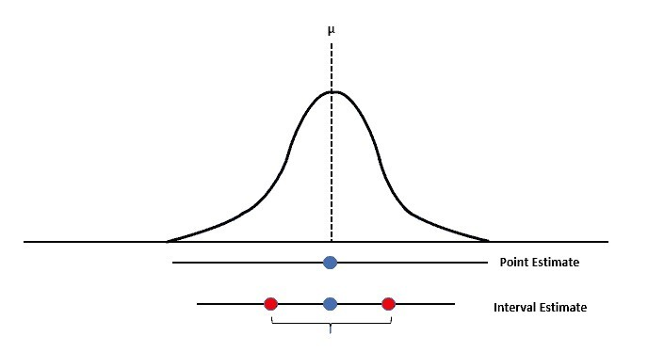

Interval Estimation Continued

* Point estimators are not perfect!
* An **interval estimate** is used to hopefully capture the true value

Point estimate  Margin of error

*x*  Margin of error

*p*  Margin of error



Interval Estimation

**Interval Estimation of the Population Mean (cont.):**

For any normally distributed random variable:

* 90% of the values lie within 1.645 standard deviations of the mean.
* 95% of the values lie within 1.960 standard deviations of the mean.
* 99% of the values lie within 2.576 standard deviations of the mean.



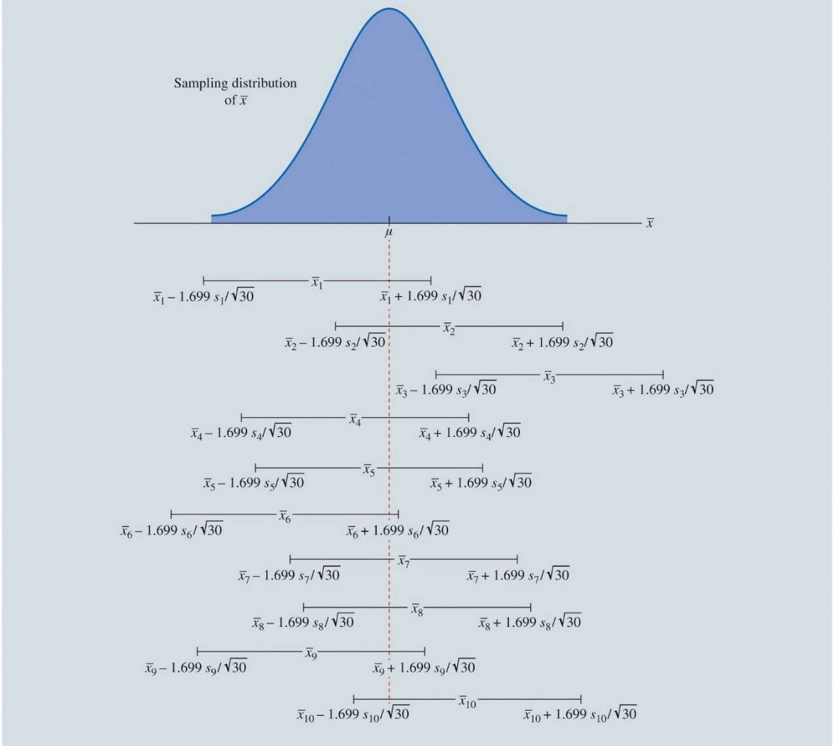

EAI Managers

* Recall:
  + N = 30 managers
  + Sample mean salary (𝑥) = $71,814
  + Sample SD (s) = $3,340
* 𝑥 + 1.699(3340/ 30)

◆ = $70,778 to $72,850

* The True Population Mean =

$71,800

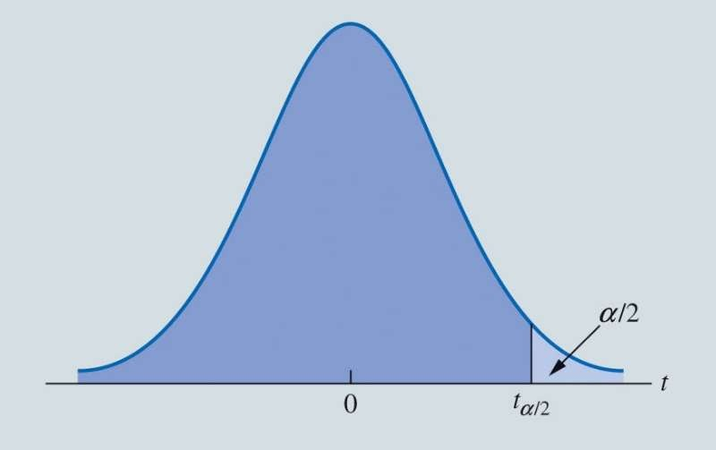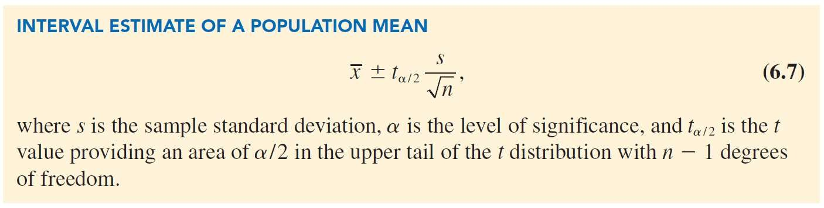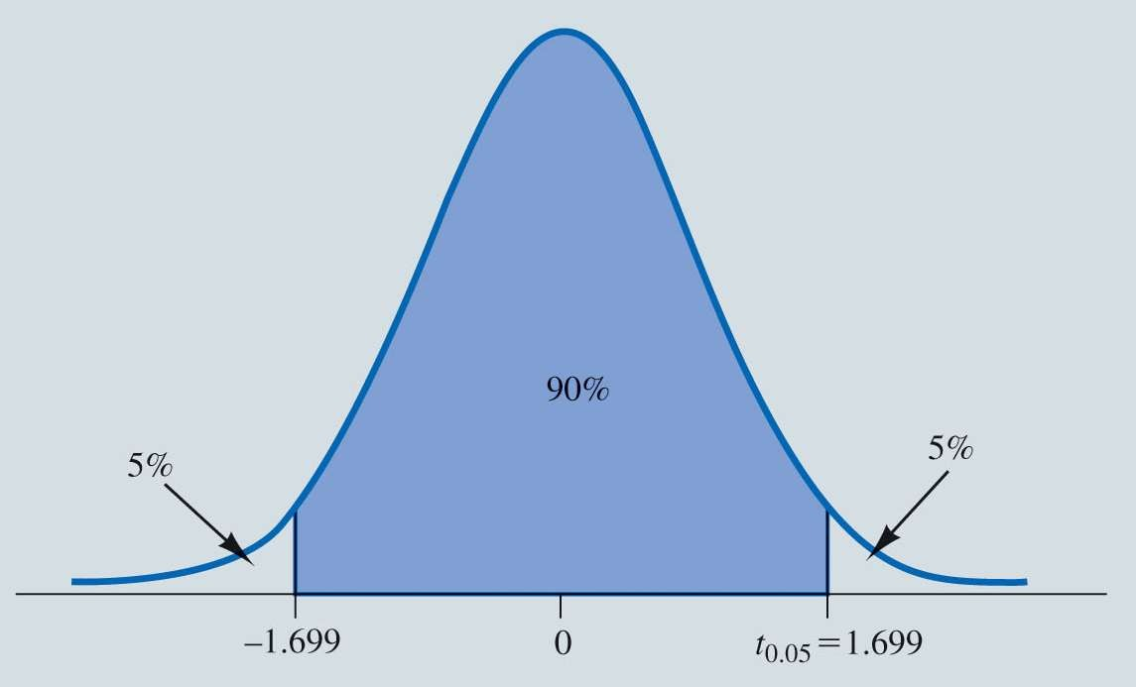

Interval Estimation

t Distribution with α Area or Probability in the Upper Tail

2



Another Example

Table 6.5: Credit Card Balances for a Sample of 70 Households

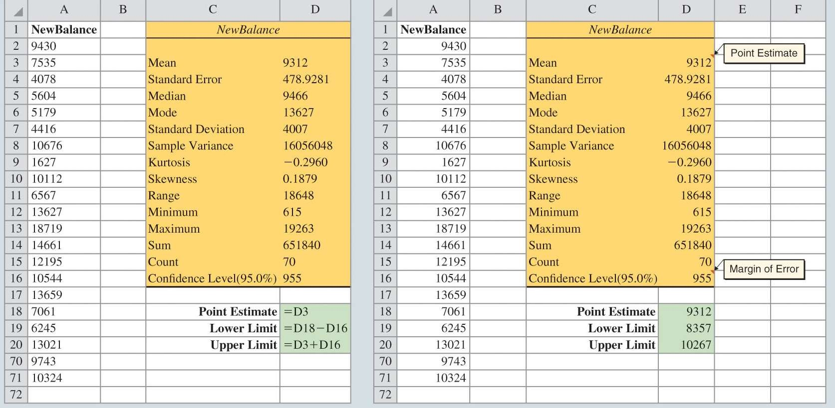

|  |  |  |  |  |  |
| --- | --- | --- | --- | --- | --- |
| 9,430 | 14,661 | 7,159 | 9,071 | 9,691 | 11,032 |
| 7,535 | 12,195 | 8,137 | 3,603 | 11,448 | 6,525 |
| 4,078 | 10,544 | 9,467 | 16,804 | 8,279 | 5,239 |
| 5,604 | 13,659 | 12,595 | 13,479 | 5,649 | 6,195 |
| 5,179 | 7,061 | 7,917 | 14,044 | 11,298 | 12,584 |
| 4,416 | 6,245 | 11,346 | 6,817 | 4,353 | 15,415 |
| 10,676 | 13,021 | 12,806 | 6,845 | 3,467 | 15,917 |
| 1,627 | 9,719 | 4,972 | 10,493 | 6,191 | 12,591 |
| 10,112 | 2,200 | 11,356 | 615 | 12,851 | 9,743 |
| 6,567 | 10,746 | 7,117 | 13,627 | 5,337 | 10,324 |
| 13,627 | 12,744 | 9,465 | 12,557 | 8,372 |  |
| 18,719 | 5,742 | 19,263 | 6,232 | 7,445 |  |



Interval Estimation

Figure 6.13: 95% Confidence Interval for Credit Card Balances

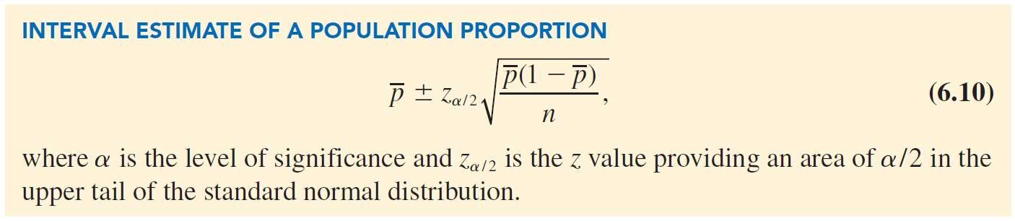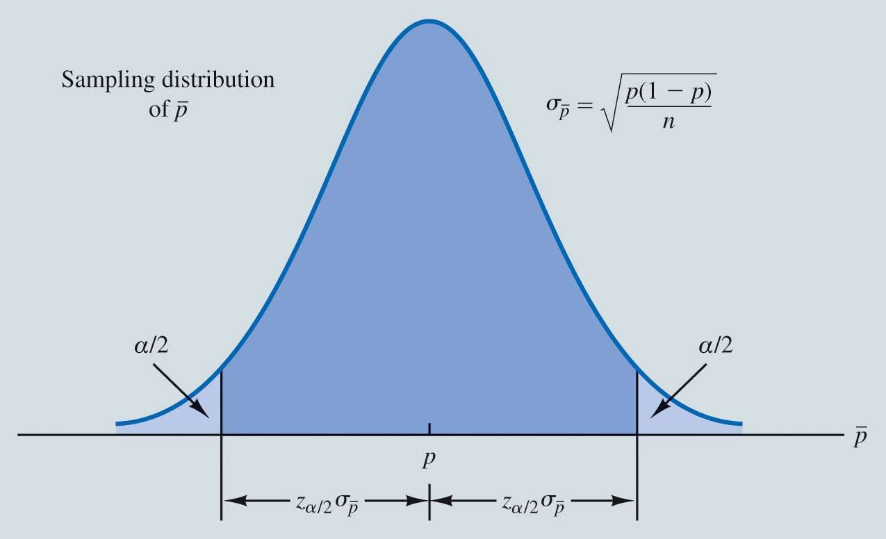

Interval Estimation

**Interval Estimation of the Population Proportion:**

*p*  Margin of error

The sampling distribution of *p* plays a key role in computing the margin of error in the interval estimate.



Interval Estimation

Figure 6.14: Normal Approximation of the Sampling Distribution of *p*

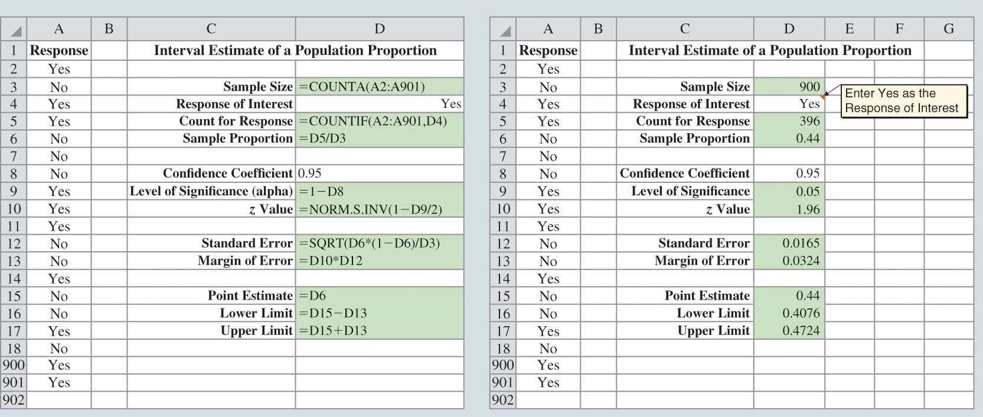

Interval Estimation

Figure 6.15: 95% Confidence Interval for Survey of 900 Women Golfers Are you satisfied with your tee times?



Hypothesis Tests

Developing Null and Alternative Hypothesis Type I and Type II Errors

Hypothesis Test of the Population Mean Hypothesis Test of the Population Proportion



Hypothesis Tests

* Statistically deciding if a statement about a parameter should be accepted or rejected
  + The average mpg of a vehicle is <= 24
  + The average Gatorade in a bottle is at least (>=) 67.6 ounces
* **Null hypothesis**
  + The tentative conjecture
* **Alternative hypothesis**
  + The opposite of what is stated in the null hypothesis
* Using data from a sample, we can test the validity of the two competing statements about a population.



Hypothesis Tests

**Developing Null and Alternative Hypotheses:**

* Context is KEY!
  + The context determines how the hypotheses should be stated
* **Ask:**
  + What is the purpose of collecting the sample?
  + What conclusions are we hoping to make?

# Hypothesis Tests

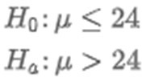

## The Alternative as a Research Hypothesis

* + Current car gets 24 mpg
  + New fuel system
    - Better than 24 mpg
  + Several cars are built with new fuel system and tested
* Make the alternative the conclusion the research hopes to support

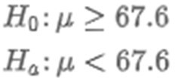



Hypothesis Tests

* **The Null Hypothesis as a Conjecture to be Challenged**
  + Bottle label states: 67.6 fl ounces
  + Assume correct if average fill is at least 67.6 fl ounces
  + Gather sample and test



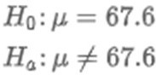

Hypothesis Tests

* **The Null Hypothesis as a Conjecture to be Challenged**
  + **(From Company Perspective)**
  + Bottle label states: 67.6 fl ounces
  + Don’t want to underfill or overfill bottles
  + Gather sample and test



Hypothesis Tests

* Depending upon the situation, hypothesis tests about a population parameter may take one of three forms:

*H*0 : **  **0

*Ha* : ** < **0

*H*0 : **  **0

*Ha* : ** > **0

*H*0 : ** = **0

*Ha* : **  **0

* First two forms are called one-tailed tests.
* Third form is called a two-tailed test.



Hypothesis Tests

**Type I and Type II Errors:**

* Example:
  + Type 1: RMeasneaisrcinhneorscesnaty,tbhuetMhPeGgeotns tsheentneenwcesdysttoemlifeis ibneptrtiesronthan 24, when its really not.
  + Type 2: RMeasneaisrcghueilrtsy,sabyutthhee MgePtGs osentnferwees.ystem is no better than the old, when it really is.



|  |  |  |
| --- | --- | --- |
|  | ***H*0 True** | ***Ha* True** |
| **Do Not Reject**  ***H*0** | Correct Conclusion | Type II Error |
| **Reject**  ***H*0** | Type I Error | Correct Conclusion |



Hypothesis Tests

* **Level of Significance:**
  + Probability of making a Type 1 Error
    - The **level of significance (Alpha) or if Confidence level – 95%**
    - **Alpha = 5%**
  + Usually, hypothesis tests control for Type I errors
    - Potentially Worse conclusion
  + Type II errors can be controlled for
    - **Usually just say “Fail to Reject Ho”**



Hypothesis Tests

**Hypothesis Test of the Population Mean:**

* **One tailed tests** about a population mean take one of the following forms:

Lower-Tail Test

*H* : **  **

Upper-Tail Test

*H* : ** < **

0

0

*H* : **  **

0

0

*a*

0

*H* : ** > **

*a*

0

1. Develop the null and alternative hypothesis for the test.
2. Specify the level of significance for the test.
3. Collect the sample data and compute the value of what is called a test statistic.

# Example

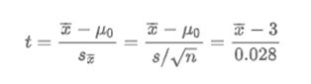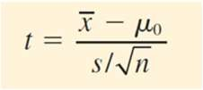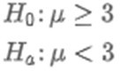

### Hilltop Coffee

* + States each can of coffee contains 3 lbs of coffee

### Federal Trade Commission (FTC) wants to check

* + Alpha = 0.01 (1%)

### Test Statistic for Hypothesis Test About a Population Mean

* + Does 𝑥 deviate from the hypothesized 𝜇 enough to justify rejecting the Null Hypothesis?

# Example



### We find out our sample mean is 2.92

* Test Statistic = -2.824

### Is this small enough to lead us to reject the Null?

* + Is there support that the cans of coffee do not have 3lbs of coffee?

**How small must the test statistic *t* be before we choose to reject the null hypothesis?**

* ***P* Value:**
  + Probability, assuming the Null is true, of obtaining a random sample of size n that results in a test statistic at least as extreme as the one observed in the current sample

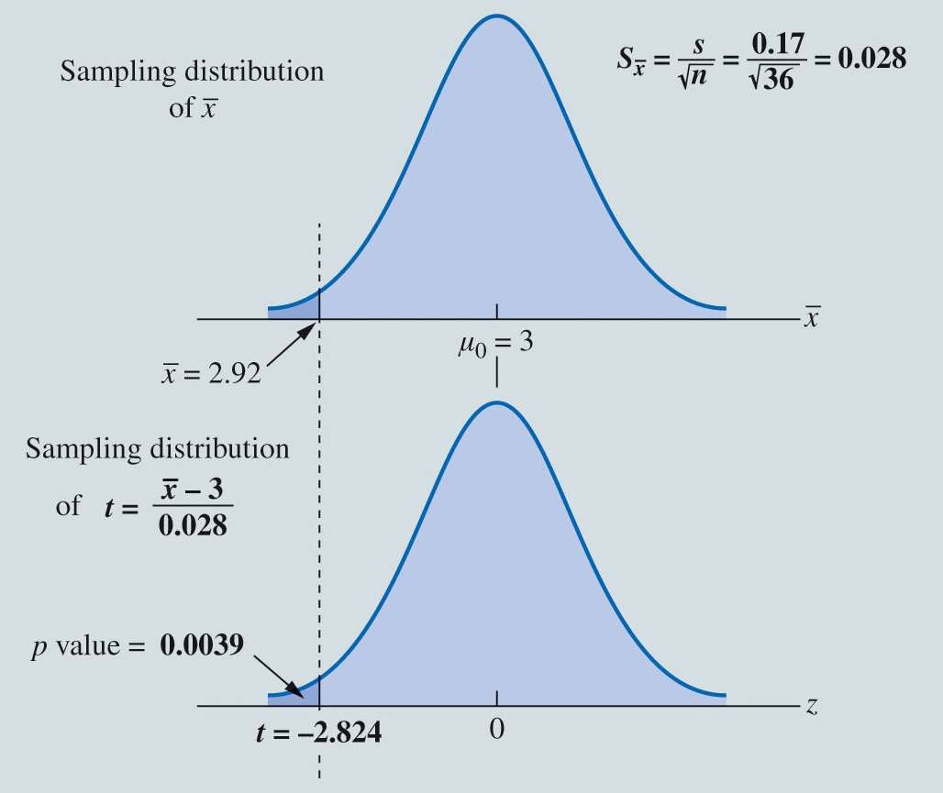

Hypothesis Tests

Figure 6.19: 𝑝 Value for the Hilltop Coffee Study When 𝑥 = 2.92 and 𝑠

= 0.17

**Alpha = 0.01**

**P value = 0.0039**

* The probability of obtaining a value of 2.92 lbs or less when the null hypothesis is true is 0.0039 (.39%)
* Since this is less than 0.01, we reject the Null.
* There is statistical evidence that the cans of coffee do not have 3lbs in them



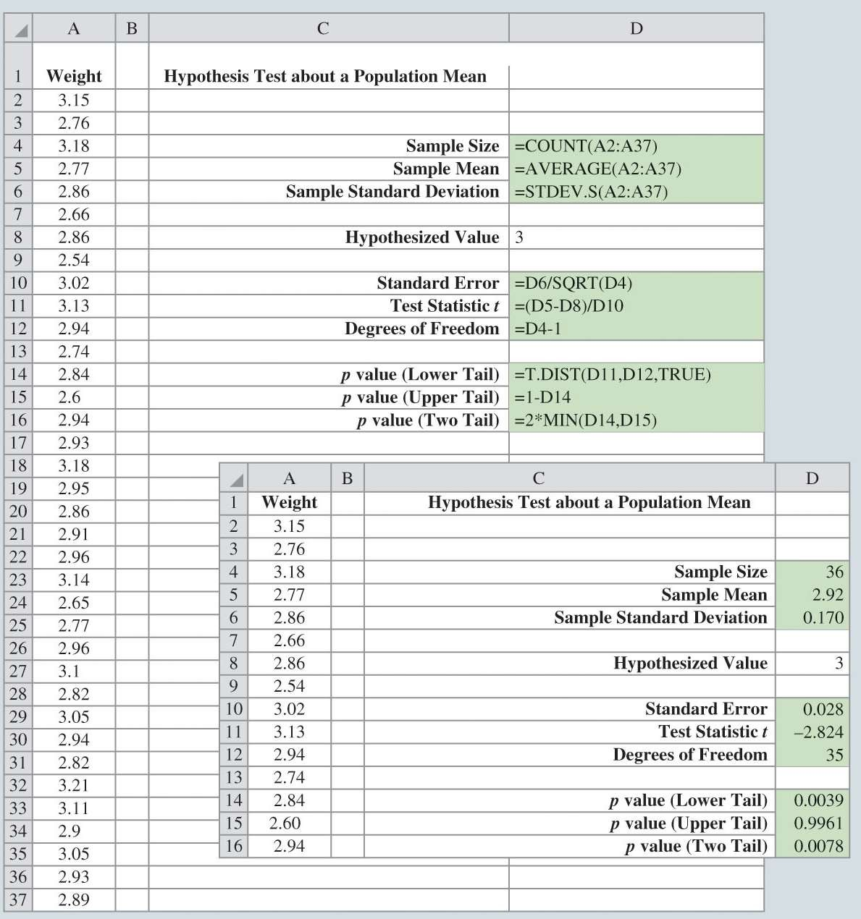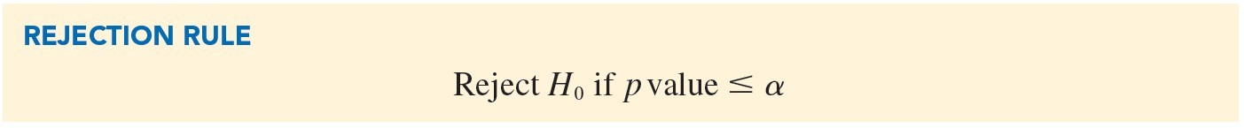

Hypothesis Tests

Figure 6.18: Hypothesis Test about a Population Mean

CoffeeTest.xlsx



Hypothesis Tests

* The level of significance indicates the strength of evidence that is needed in the sample data before rejection of the null hypothesis.
* Different decision makers may express different opinions concerning the cost of making a Type I error and may choose a different level of significance.
* Providing the *p* value as part of the hypothesis testing results allows decision makers to compare the reported *p* value to his or her own level of significance.
  + Typically less than 0.1 (10%) is widely accepted.



Hypothesis Tests

* Upper-tail test:
  + Using the *t* distribution
  + Compute the probability that *t* is greater than or equal to the value of the test statistic (area in the upper tail).

Upper-Tail Test

*H* : **  **

*H* : ** > **

0

0

*a* 0

In hypothesis testing, the general form for a **two-tailed test** about population mean is:

*H*0 : ** = **0

*Ha* : **  **0

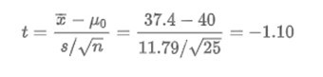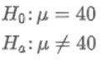

Example

* Holiday Toys
  + Expected demand for new toy
    - 40 units per retail outlet
  + Survey 25 retailers – anticipated order quantity
* From the sample
  + 𝑥 = 37.4 and SD = 11.79 units
* Test Statistic
* If Null rejected – reevaluate production plan
* Two-Tailed Test
  + Must find the probability of obtaining a value for test statistic that is at least as likely as -1.10

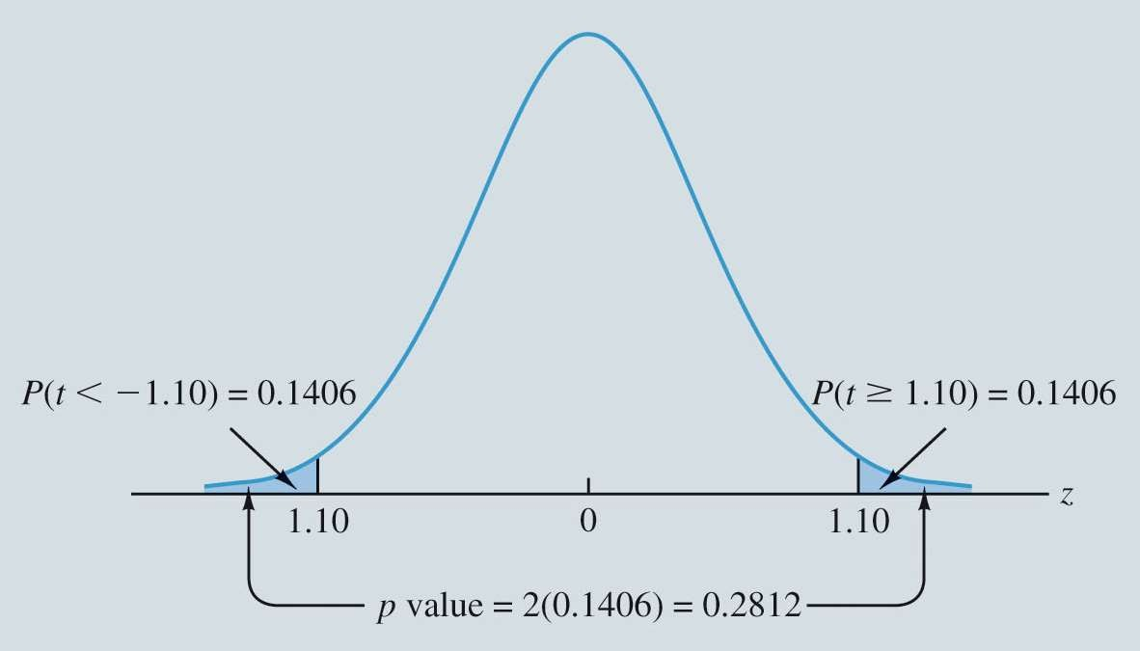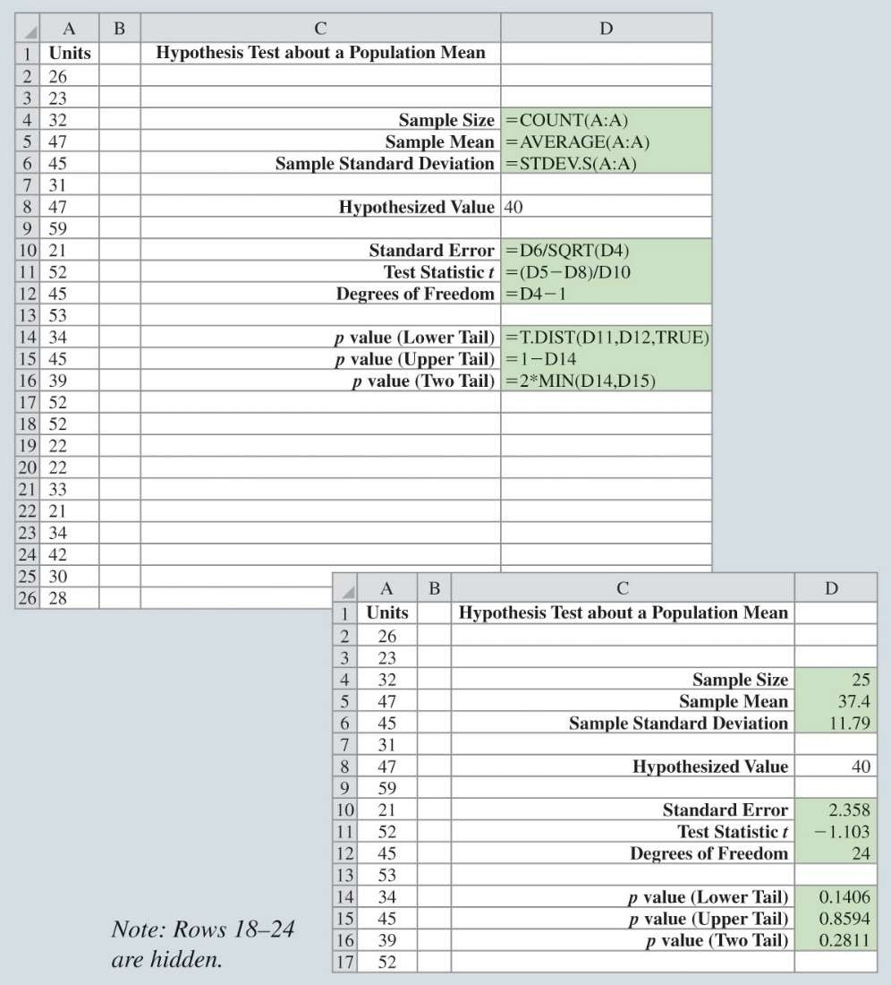

Hypothesis Tests

Figure 6.20: *p* Value for the Holiday Toys Two-Tailed Hypothesis Test

* Computation of *p* Values for Two-Tailed Tests:
  1. Compute the value of the test statistic.
  2. Compute the p value for one of the tail areas.
  3. Double the probability (or tail area) from step 2 to obtain the final *p* value.
* Conclusion:
* 0.2812 > 0.05
* Fail to Reject the Null –
* Holiday Toys can make 40 toys for each retail location



Hypothesis Tests

Figure 6.21: Two-Tailed Hypothesis Test for Holiday Toys

OrdersTest.xlsx

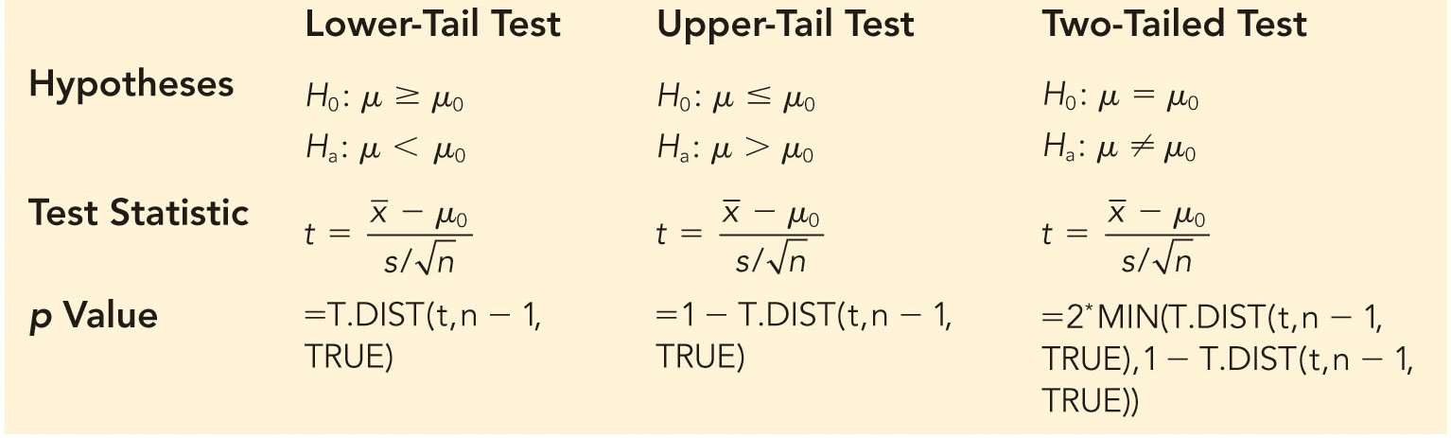

Hypothesis Tests

Table 6.7: Summary of Hypothesis Tests About a Population Mean



Hypothesis Tests

Steps of Hypothesis Testing:

**Step 1.** Develop the null and alternative hypotheses.

**Step 2.** Specify the level of significance.

**Step 3.** Collect the sample data and compute the value of the test statistic.

**Step 4.** Use the value of the test statistic to compute the *p* value.

**Step 5.** Reject

*H*0 if the *p*  **.

**Step 6.** Interpret the statistical conclusion in the context of the application.

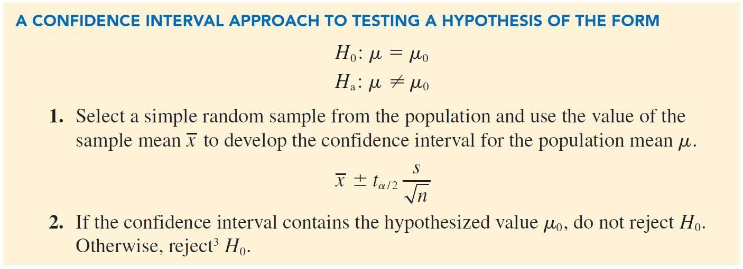

Hypothesis Tests



Hypothesis Tests

Hypothesis Test of the Population Proportion:

* The three forms for a hypothesis test about a population proportion are:

*H*0 : *p*  *p*0

*Ha* : *p* < *p*0

*H*0 : *p*  *p*0

*Ha* : *p* > *p*0

*H*0 : *p* = *p*0

*Ha* : *p*  *p*0

* The first form is called a lower-tail test.
* The second form is called an upper-tail test.
* The third form is called a two-tailed test.

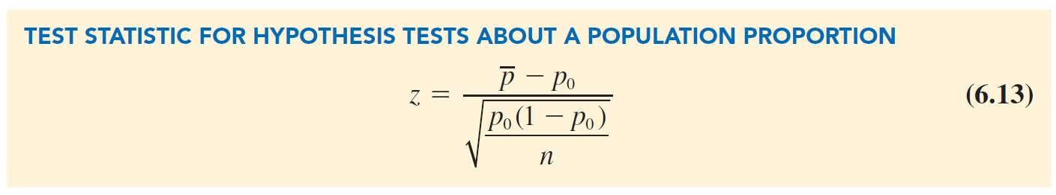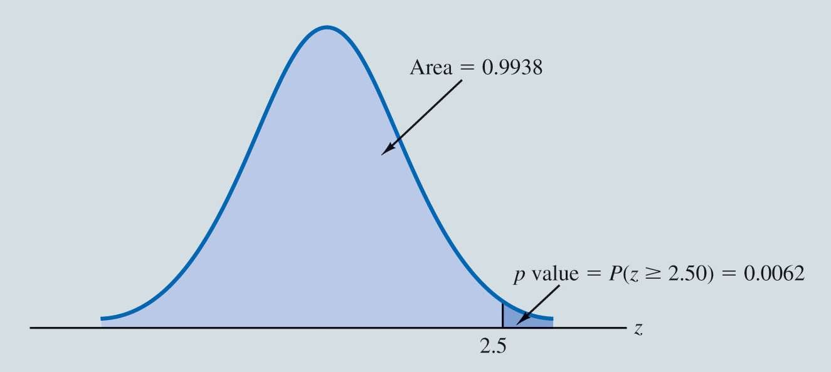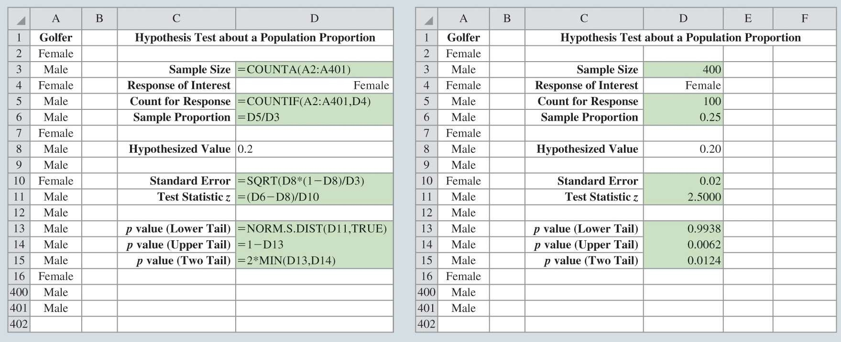

Hypothesis Tests

Figure 6.22: Calculation of the *p* Value for the Pine Creek Hypothesis Test



Hypothesis Tests

Figure 6.23: Hypothesis Test for Pine Creek Golf Course Womengolf.xlsx

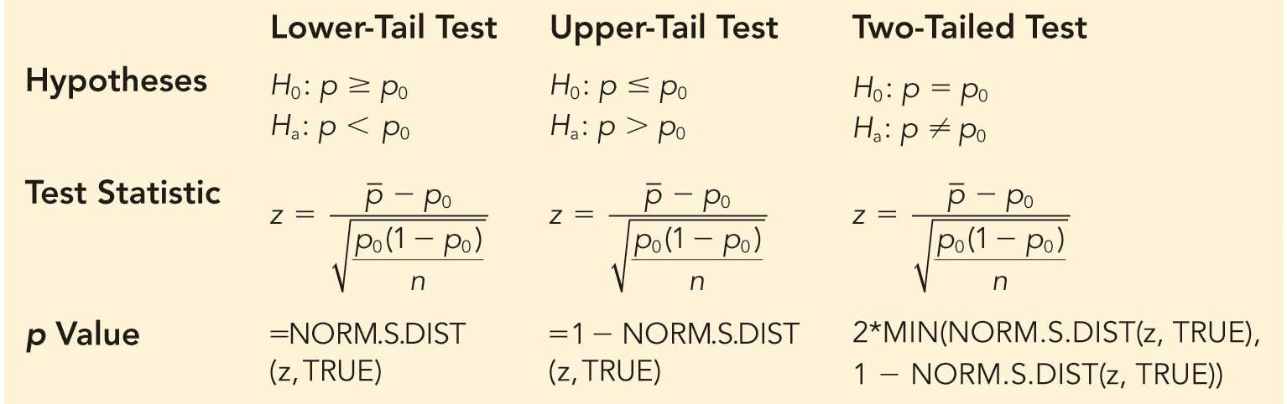

Hypothesis Tests

Table 6.8: Summary of Hypothesis Tests About a Population Proportion